ПИ

ИСиТ, ДЕВИ

Лекция XX

**Web/GUI-Приложения Nancy.Hosting.Self**

1. **Nancy**: View engines:

* Supper Simple View Engine (html/sshtml);
* Razor View Engine (cshtml);
* Custom View Engine.

1. **Nancy**: конвенция о расположении представлений

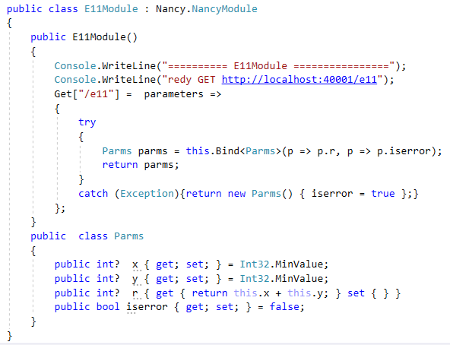

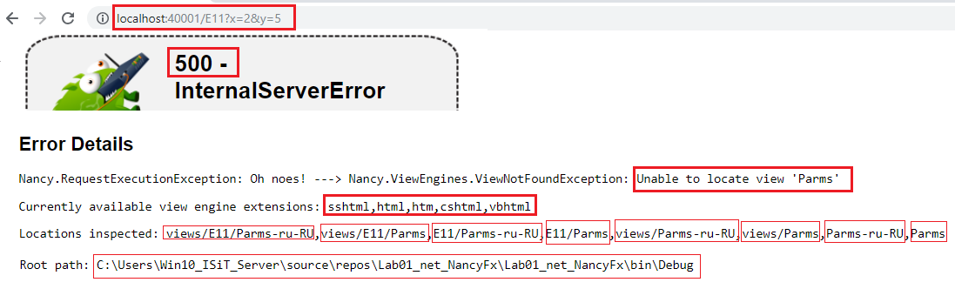

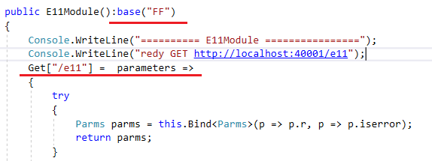

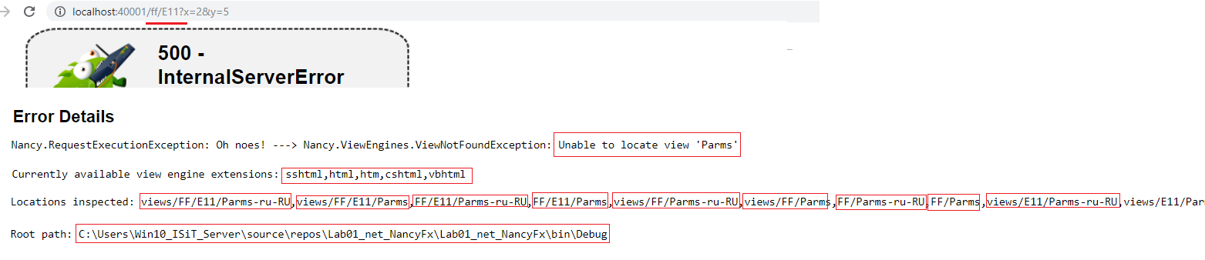

1. **Nancy**: Supper Simple View Engine (html/sshtml)

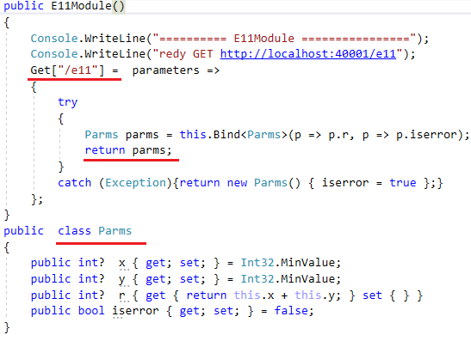

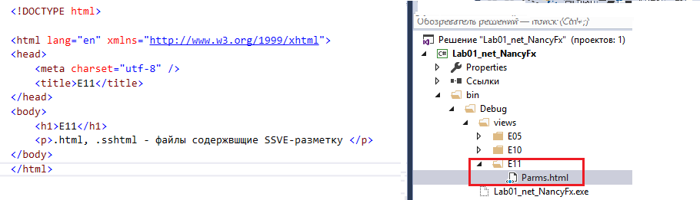

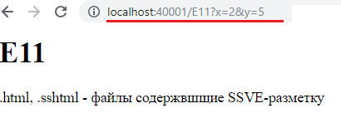

1. **Nancy**: SSVE(html/sshtml), Model

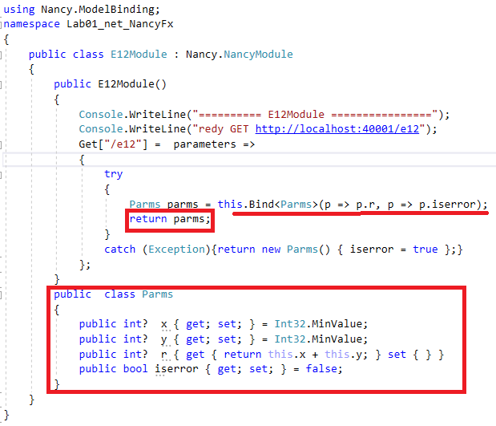

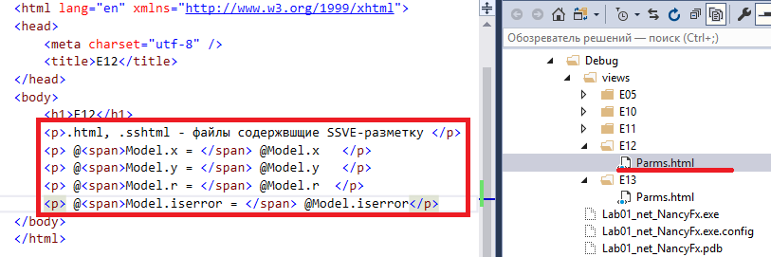

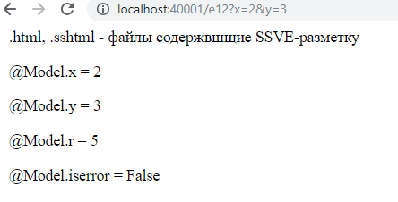

1. SSVE(html/sshtml), ViewBag

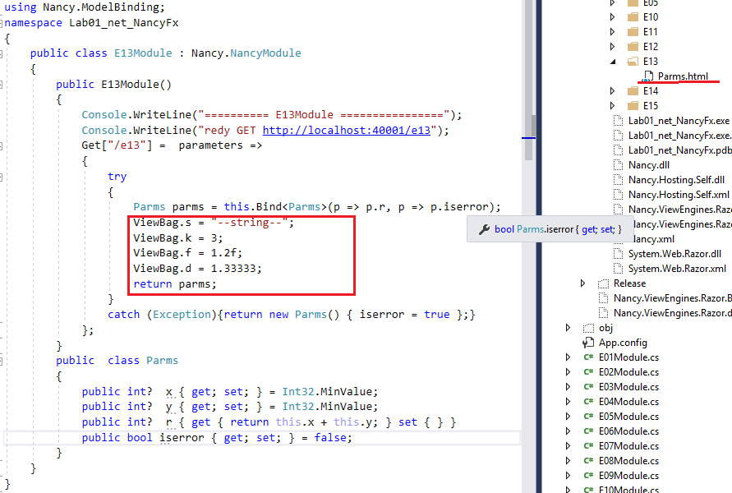

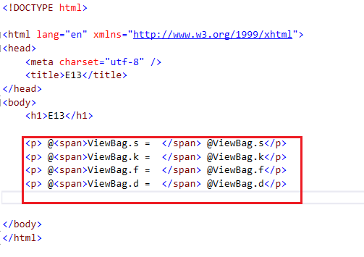

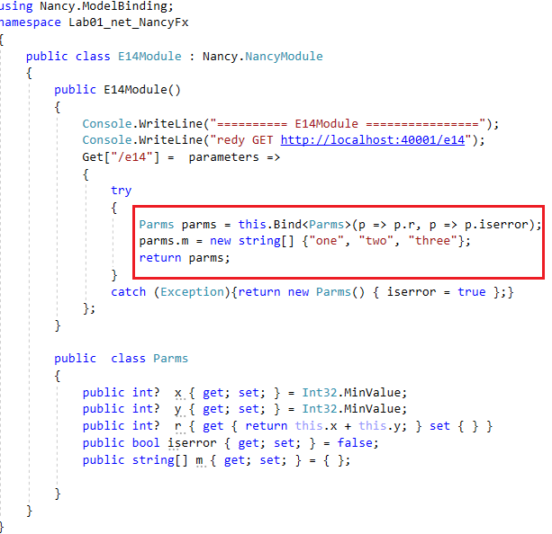

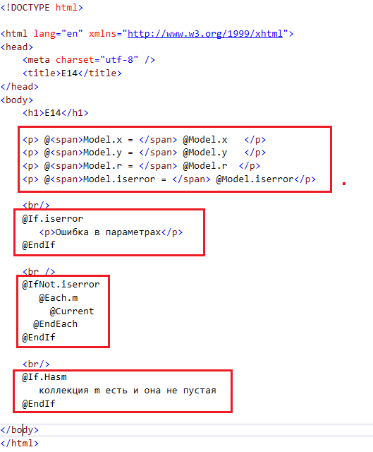

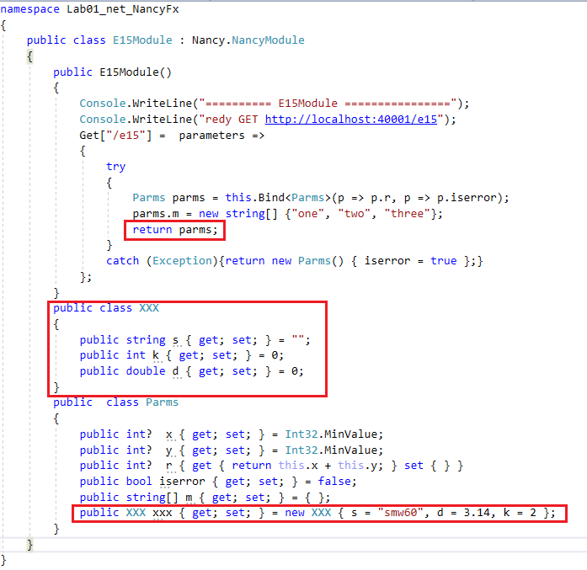

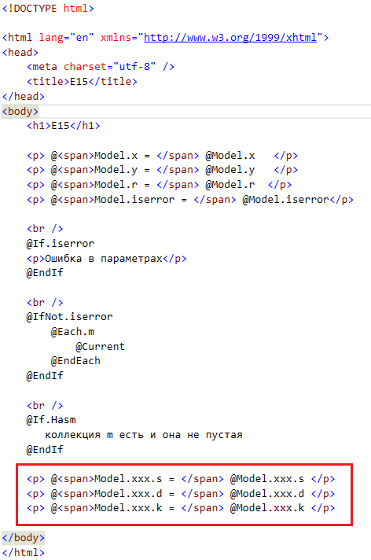

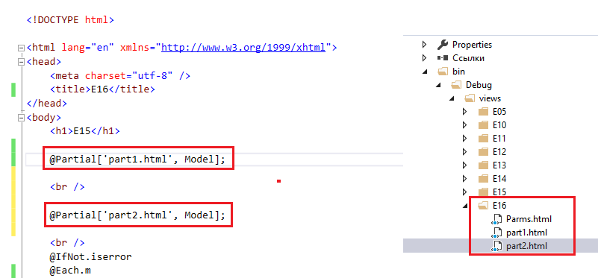

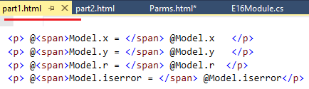

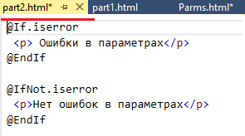

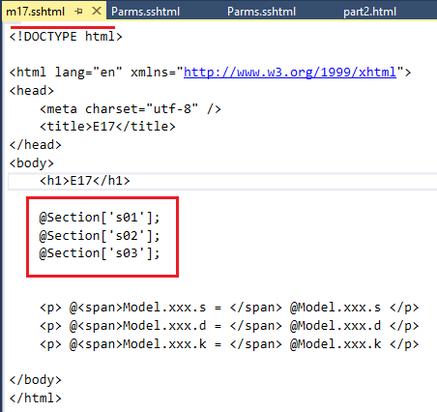

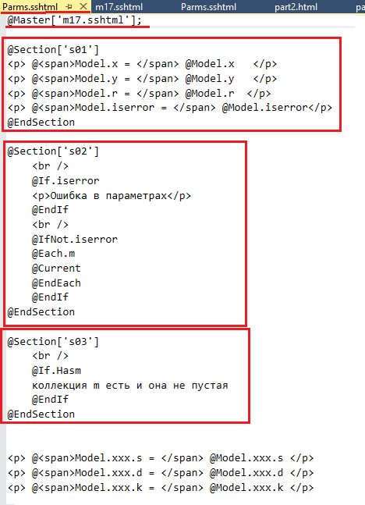

1. **Nancy**: Razor (cshtml)

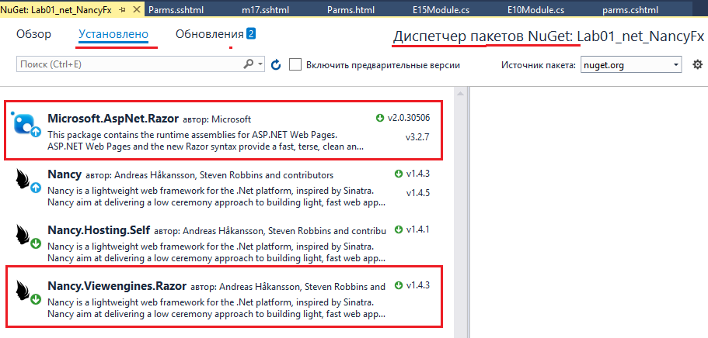

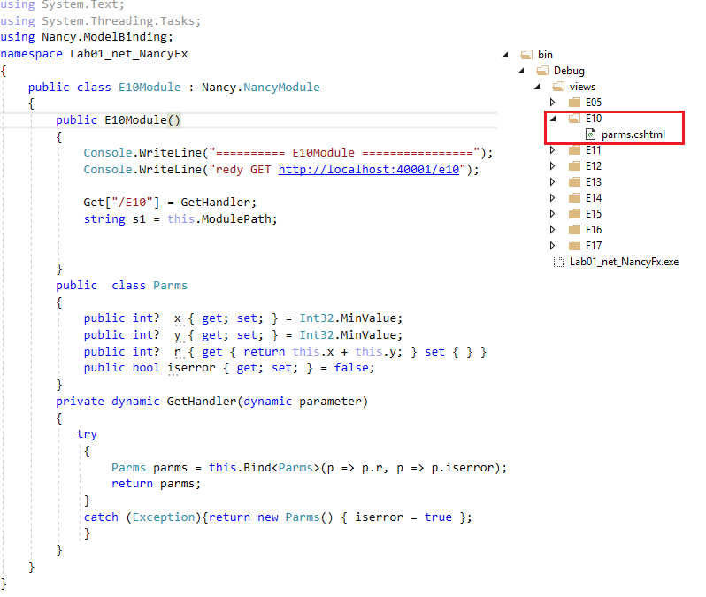

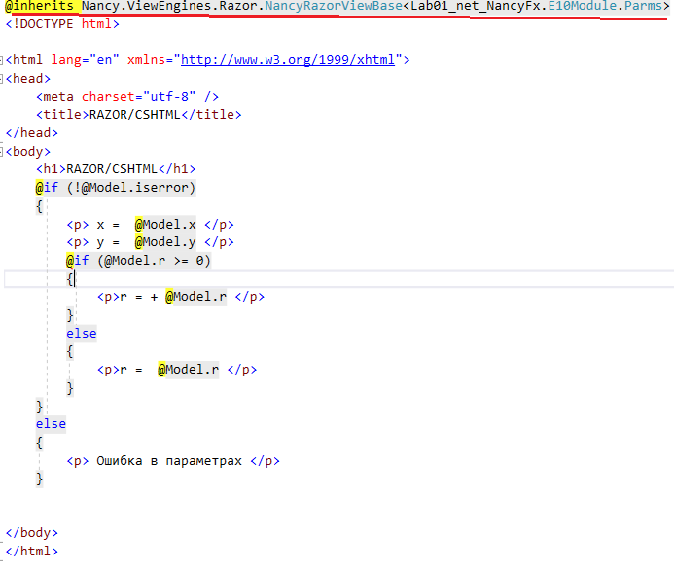

1. **Ааа**
2. **Аа**
3. **Ааа**
4. **Аа**
5. **Аа**
6. **Аа**
7. **Аа**